**Project Development Log – Joseph Henry**

**Prototype 1 Development (The Multiplayer):**

I first made a basic client program that opened a display window; this will be used to display the game to the players.

import pygame  
displayWidth = 500  
displayHeight = 500  
gameDisplay = pygame.display.set_mode((displayWidth, displayHeight))  
def main():  
 run = True  
 while run:  
 print("running")  
 pygame.quit()  
main()

This worked just as expected by displaying a small box on the screen and printing the word “running” in the console continuously until the code was stopped from running.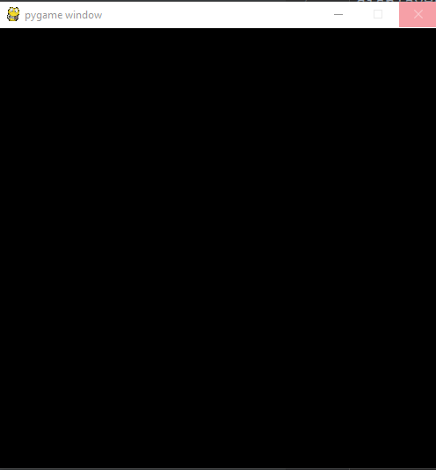

**Prototype 2 Development (Spawn Zone and Physics):**

**Prototype 3 Development (Map Generation):**